Introduction to Functions Between Sets
A function between two sets is a rule that assigns each element of one set to exactly one element of another set.
Suppose we have two sets:
A = {1, 2, 3, 4} and B = {10, 20, 30}
A function from A to B can be written as:
$$f:A→B$$
This means that f maps elements of set A to elements of set B.
B
A
For example:
10
20
30
1
2
3
4
f(1) = 10,
f(2) = 20,
f(3) = 20,
f(4) = 30
This function is represented in the above diagram.
A function f from A to B, $f:A→B$ is a relation that satisfies two conditions:
Condition 1: Every element of A must be mapped (No element in the domain can be left without an image.)
Condition 2: Each element of A must have exactly one image (An element cannot point to two different elements).
For example:
B
A
The relation represented in diagram is a valid function
10
20
30
1
2
3
4

But a relation in following diagram is not a valid function because an element 3 from set A has two images.
B
A
1
2
3

10
20
30

Similarly, following relation is not a function, as an element 3 has no image.
A
B
10
20
30
1
2
3
4

Domain, Co-domain and Range
Consider a function $$f:A→B$$
where A = {1, 2, 3, 4} and B = {10, 20, 30}
with f(1) = 10, f(2) = 20, f(3) = 20, f(4) = 30.
Domain
It is the complete set of all possible values which qualify as inputs to a function – the set from which elements are mapped.
Domain = A = {1, 2, ,3, 4}
Co-domain
It is the set of all possible outcomes of the given function - the set into which elements are mapped.
Co-domain = B = (10, 20, 30}
Range
The set of all actual outputs – the elements of co-domain that actually receive an arrow
Here Range = {10, 20, 30}
Difference between Range and Co-domain
Consider a function $$f:A→B$$
where A = {1, 2, 3} and B = {10, 20, 30, 40, 50} with f(1) = 10, f(2) = 20, f(3) = 30.
In this case
Domain = A = {1, 2, 3}
Co-domain = B = {10, 20, 30, 40, 50}.
But Range = {10, 20, 30}
Types of functions

Injective (One-to-one)
Surjective (Onto)
Bijective (One-to-one and Onto)

1. Injective function (One-to-one function)
Different elements of Domain have different images in Codomain.
If a₁​ and a₂ are different elements in Domain, then they have different images – f(a₁) and f(a₂) in Co-domain.
${If a}_{1}≠ a_{2}$, then ${f(a}_{1})≠ f(a_{2})$
Example:
Let A = {1, 2, 3} and B = {10, 20, 30, 40}
And f(1) = 10, f(2) = 20 and f(3) = 30.
This is Injective function as every element of Domain is mapped to different element in Co-domain.
B
A
10
20
30
40
1
2
3

In the above arrow diagram, no two elements of A point to a same element of B. Notice that 40 is unused. That's perfectly okay for an injective function.
But the function represented by following arrow diagram is not Injective.
B
A
10
20
30
40
1
2
3

Because, here f(2) = f(3) = 20, i. e. Two different inputs, 2 and 3, have same output 20.

2. Surjective function (Onto function)
A function $f:A→B$ is called Surjective if every element of Co-domain B is mapped by at least one element of A.
Every element of Co-domain must receive at least one arrow.
In this case, Range = Co-domain.
Example:
Let A = {1, 2, 3, 4} and B = {10, 20, 30}. A function $f:A→B$ is defined as
f(1) = 10, f(2) = 20, f(3) = 30 and f(4) = 20.
Here Range of f = {10, 20, 30} = set B, that is Range = Co-domain
Similarly, if the function f is represented by an arrow diagram as shown below
B
A
10
20
30
1
2
3
4

Every element of B — 10, 20 and 30 — has at least one arrow.
Therefore, a function f is surjective.
Note that, it is perfectly acceptable for two inputs to have the same output.
But, we consider following function $g:A→B$ is defined as
g(1) = 10, g(2) = 10, g(3) = 20 and g(4) = 20.
Here Range of g = {10, 20} $≠$ set B, that is Range $≠$ Co-domain
Hence a function g is not Surjective.
A
B
10
20
30
1
2
3
4

This can be confirmed by the above arrow diagram of function g. An element 30 does not receive any arrow.

3. Bijective function (One-to-one and Onto function)
A bijective function is a function that is both injective (one-to-one) and surjective (onto).
Every element in the codomain is mapped by exactly one element of the domain.
Example
A = {1, 2, 3} and B = {10, 20, 30}. consider a function $f:A→B$ is defined as
f(1) = 10, f(2) = 20 and f(3) = 30.
This function is Bijective function because
- No two elements of the domain A have the same image.
- Every element of the codomain B is used.
Its representation in arrow diagram is
A
B
10
20
30
1
2
3

Examples
1) Let A = {1, 2, 3} and B = {x, y, z}. The function $f:A→B$ is defined as f(1) = x, f(2) = y and f(3) = z. Determine the type of function by using an arrow diagram.
2) Let A = {1, 2, 3} and B = {x, y, z, w}. The function $f:A→B$ is defined as f(1) = x, f(2) = y and f(3) = z. Determine the type of function by using an arrow diagram.
3) Let A = {1, 2, 3, 4} and B = {x, y, z}. The function $f:A→B$ is defined as f(1) = x, f(2) = y, f(3) = z and f(4) = y. Determine the type of function by using an arrow diagram.
4) Let A = {1, 2} and B = {x, y, z}. The function $f:A→B$ is defined as f(1) = x, f(2) = x. Determine the type of function by using an arrow diagram.
5) Determine the type of function represented by an arrow diagram with reason.
a) 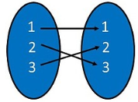 b) 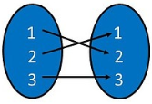 c) 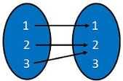

d) e) f) 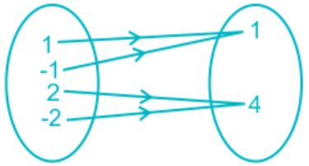
1
2
3
1
2
3
4
1
2
3
4
1
2
3
g) 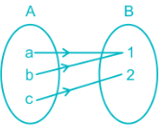 h) 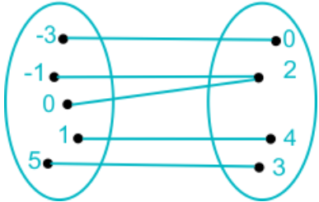
6) Determine the Domain, Co-domain and Range of the above functions asked in examples questions from Q(1) to Q(5).

